Time at the Light Speed

By

Toshio Suzuki

World Government Institute

© Copy Right, Toshio Suzuki, February 2015

All rights reserved.

Toshio Suzuki
World Government Institute Japan
1-158 Nakakanasugi Matsudo City, Chiba Prefecture, 270-0007, Japan
Web Site: http://www.w-g.jp/

CONTENTS

CONTENTS iii
PREAMBLE 5
I BASIC KNOWLEDGE 5
1. Basic Knowledge 5
A. Time Stops When an Object Moves at the Light Speed 5
B. An Object Becomes a Line When an Object Moves at the Light Speed 7
II. ASSUMPTION 9
Field of Soul-Energy 9
III ACTUAL PHENOMENA 11
1. Explanation Why the Time Stops When an Object Moves at the Light Speed 11
2. Explanation Why an Object Becomes a Line When the Object Moves at the Light Speed 28
3. Conclusion 29
SELECTED BIBLIOGRAPHY 31

PREAMBLE

Basic thought of this paper is written in Soul Federation. After publishing this book, a new important idea emerged in my mind. So, I write this paper. Most part of this paper was copied from Soul Federation. So, in the original contents, some parts were not understandable without reading the book. To avoid this, here, such parts are explained in advance. First, I often used words such as "god" or "soul". Basically, I think the god is the soul in the Spirit World. Thus I believe in the Spirit World. Furthermore, I wrote about Planet-Christian or Planet-Japanese. I assumed that there were Planet-Christian or Planet-Japanese. Theses planets were destroyed or became uninhabitable and so souls on theses planets came to Earth. I would like readers to remember these as basic knowledge.
This paper aims to show a new idea on the time. Here, the time means the time in a sense of common sense or the time of the theory of relativity of Albert Einstein (1879-1955). It is famous that in the Einstein's theory of relativity, when an object moves at the light speed, the time stops and the object becomes a line. This paper does not fundamentally deny this theory. This paper tries to explain these phenomena from a different point of view.
Thoughts on this paper have not been scientifically verified. They are results of my imagination. But, mere imagination is valuable if it is closer to the truth than conventional thoughts.

I BASIC KNOWLEDGE

1. Basic Knowledge

Here, we will review some basic knowledge of Einstein's theory of relativity.

A. Time Stops When an Object Moves at the Light Speed

Einstein insisted that if an object moves at the speed of light, the time stops. It is very famous that this Einstein’s thought is called the theory of relativity. In Einstein’s theory of relativity, there are the special theory of relativity and the general theory of relativity. Here, we consider the special theory of relativity. The theory of relativity is based on two postulates:

1. The laws of physics are the same for all observers in uniform motion relative to one another (Galileo’s principle of relativity).
2. The speed of light in a vacuum is the same for all observers, regardless of their relative motion or of the motion of the source of the light.

First postulate means that we are in a world that we can understand by common sense. For example, when we are on a jet plane, the laws of physics are applicable for people on the jet plane. But for people on the ground, the movement in the jet plane is not explained by the laws of physics. For example, for people on the jet plane, if we drop a spoon in the jet plane, the spoon drops as if it were dropped by a person on the ground. But for people on the ground, the movement of spoon in the jet plane is not like that on the ground. This is accepted by common sense. But the second postulate is very difficult to accept by common sense. So let us see it by a figure. Figure 1 shows it.

Figure 1. Constant Speed of Light

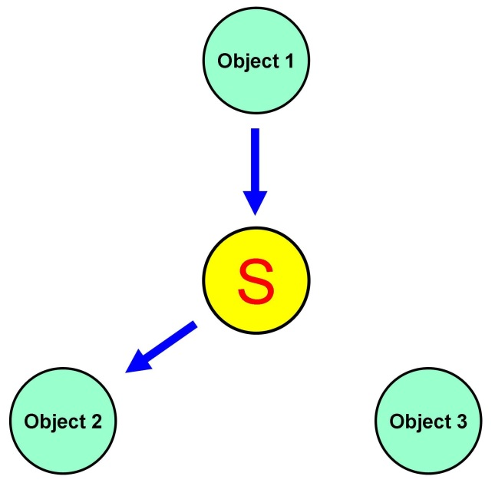

In the figure, there are one light source and three objects. Object 1 is moving toward the light source. Object 2 is moving away from the light source. Object 3 is staying at one place. In this case, the speed of light from the light source to each object is same. Namely, for each object, the light from light source comes at the same speed. Can you believe such thing? It cannot be accepted by common sense. But this phenomenon has already been verified scientifically. Einstein’s theory of relativity is based on these two postulates. His famous equation E = mc² can be derived on the basis of these two postulates. His idea is that the time is relative. As a result of his theory, the time stops when object moves at the light speed. For example, when we look at a watch, the time on the face of watch is seen differently depending on whether we are moving or not. Let us suppose there is a watch. The watch is staying at a place. There are two persons. First person is staying with the watch. Second person is moving at the light speed. For the first person, the watch is moving at ordinary speed. For the second person, the watch is not moving at all. Namely, the time is not moving. Thus, according to Einstein, if an object moves at the light speed, time stops. This phenomenon is explained in a new way that is shown below.

B. An Object Becomes a Line When an Object Moves at the Light Speed

In Einstein's theory of relativity, an object becomes a line when it moves at the speed of light. Also this phenomenon can be explained in a new way that is shown blow.

II. ASSUMPTION

Field of Soul-Energy

It is assumed that, in this world, a field of energy exists. Needless to say, there are many fields of energy such as magnetic field or field of gravitational force, etc. Here, we are concerned with the field of the Soul-Energy. The Soul-Energy is explained in more detail later. It is assumed that the speed of movement of energy depends on the strength and property of the field of Soul-Energy. Because of this feature, time stops when an object moves at the light speed. As for a theory that an object becomes a line when the object moves at the light speed, in the thought of this paper, the object does not become a line but the energy gathers into a part that is a shape of line. These are explained later.
Here we must recognize what the Soul-Energy is. It is basically based on the energy of matter. In this paper it is assumed that there are three states of soul. It is shown in the Figure 2.

Figure 2. Three States of Soul

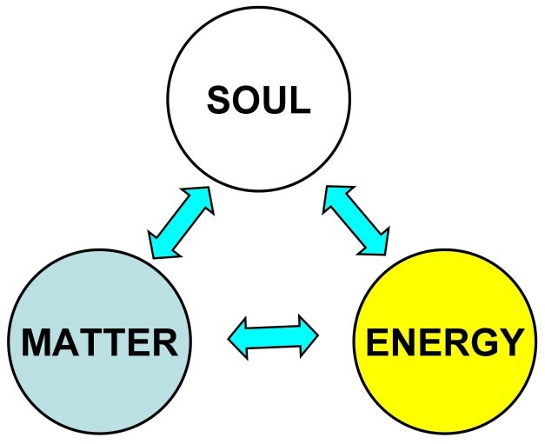
Here, soul is our mind itself. As shown in the figure, soul can change into energy and matter, energy can change into soul and matter, and matter can change into soul and energy. Energy has many states. Energy can be light energy or electric energy or kinetic energy or thermal energy, etc. Matter can exist as solid or liquid or gas. For example, in the case of water, it can be ice, water, and water vapor. We can know how soul changes into matter or energy by observing salt and water. If we dissolve salt in water, the salt disappears into water. But if the water reaches the saturation point, the salt cannot dissolve, and so it precipitates on the bottom of vessel. Like this, we cannot see the soul but the soul exists and, under certain condition, soul becomes energy or matter. Namely, souls exist in the Spirit World or the Psychic World, and the Spirit World or the Psychic World is like the salt water at the saturation point. So under certain conditions, souls become energy or matter. Namely, souls enter our real world from the Spirit World and become energy or matter. The change from matter to energy has already been shown by the theory of relativity of Einstein. The energy that emerges from matter or soul is composed of all kind of energies such as gravitational energy, static electricity, magnetic energy, etc. The Soul-Energy is composed of these energies.
The Soul-Energy forms a field of energy. In this field, the speed of movement of object and every kind of energy depends on the strength and property of the Soul-Energy. The movement of energy in the field of Soul-Energy is explained in more detail later.

III ACTUAL PHENOMENA

1. Explanation Why the Time Stops When an Object Moves at the Light Speed

The following is the second postulate of the theory of relativity.

2. The speed of light in a vacuum is the same for all observers, regardless of their relative motion or of the motion of the source of the light.

Thus, in the postulate of the theory of relativity, the speed of light in a vacuum is same for all observers, regardless of their relative motion or of the motion of the source of the light. But I think that the speed of light changes under certain condition. Let us see figure 3.

Figure 3. Refraction

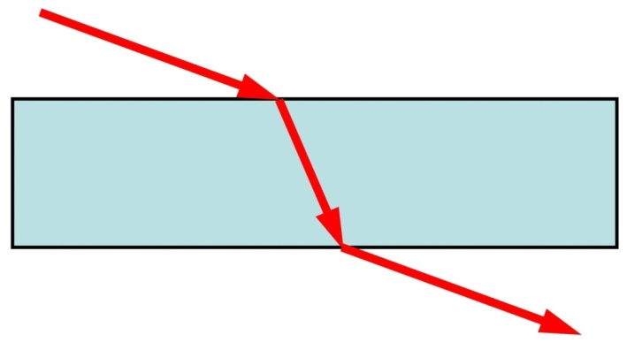

In the figure, light travels in the vacuum or atmosphere, then enters glass, and then gets out of the glass. When the light travels in the vacuum or atmosphere, the light travels at a certain speed. When the light enters the glass, the course changes and the speed slows down. But if the light gets out of glass, the course and the speed return to the former course and the speed. Same thing can be said for the sound. When the sound travels from the atmosphere into the water, it speeds up. If the sound gets out of the water and enters the atmosphere, it slows down. These happen because light and sound are waves. Thus, the speed of light varies. In general, it is said that the light travels at a constant speed in the vacuum. I think that the speed of light varies even in the vacuum space. Once, it was thought that there must be a medium that allows the light to travel. The medium was called “ether.” But, recently, it is thought that ether is not necessary. I think that in the vacuum there is energy, and the energy decides the speed of light. Then, what kind of energy is it? It is the energy that involves gravity and other energies. The energy comes from matter in the Universe. The matter is made from soul. So, it is the energy of soul. I think that the essence of gravity is the power of soul. Thus, Universe is filled with the energy of soul. This energy comes from each matter in Universe. It is shown in the figure 4.

Figure 4. Energy from Matter

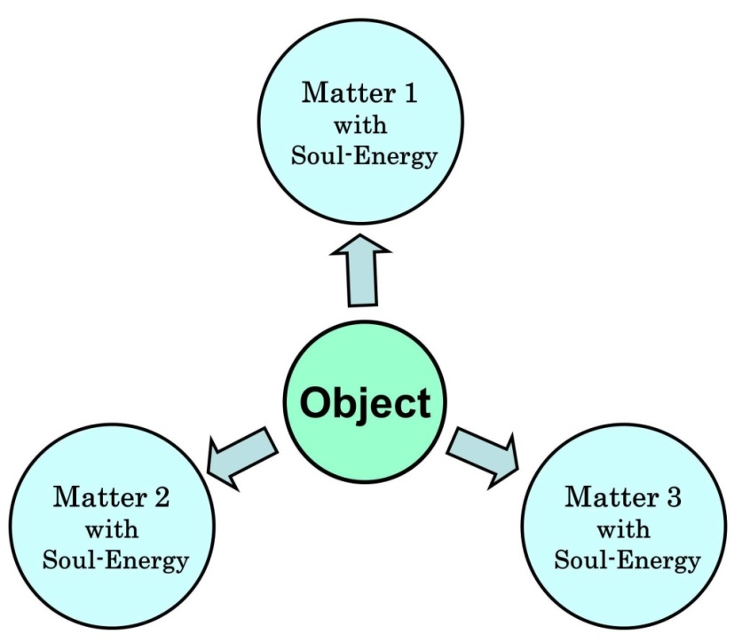

The energy is the energy of soul. So, I named this energy the Soul-Energy. Energy has its own direction. Electric current has plus and minus. Magnetic force has plus and minus. Kinetic energy has direction. Similarly, Soul-Energy has the direction. As shown in the figure, if Soul-Energy reaches an object, it has some effects including the effect of gravity. But this effect has the direction. In the figure, the Soul-Energy comes from three directions. Matter 1, Matter 2, and Matter 3 attract the object from different direction. Arrow in the figure shows the direction of gravity. In this case, each energy weakens each other. Namely, each energy neutralizes each other. So at the point of object, energy from Matter 1, Matter 2, and Matter 3 are neutralized. So the point of object is the state of zero gravity. But at the point of the object, the space is filled with Soul-Energy. Namely, the law of conservation of energy is applicable. This state is the state of Universe. The state of Soul-Energy in Universe is shown in figure 5. In the figure, Earth is in the solar system and the solar system is in the Galaxy. Galaxy is in our Universe, though Universe is not shown in the figure. Our Universe was formed after the Big Bang. There are other Universes that were formed by other Big Bangs. The size of our Galaxy is about 100,000 light-years. In our Galaxy, there are about 200 to 400 billion fixed stars. Total mass of Galaxy is about 600 billion to 3 trillion times as heavy as our Sun. If the Galaxy is reduced to 65 kilometers in diameter, the solar system is 1 millimeter in diameter. In this Galaxy, everywhere is filled with Soul-Energy. But the Soul-Energy comes from many directions, so they are neutralized. As a result, vacuum space is in the state of zero gravity. But the vacuum space is filled with Soul-Energy. Namely, in the vacuum space, Soul-Energy is neutralized, but it has the effect like that of glass shown in figure 3. So the speed of light is constant in the vacuum space where strength and property of Soul-Energy is constant. But if strength or property of Soul-Energy varies, the speed of light varies. This will be mentioned later. We can understand this situation by seeing figure 3. In the figure, light enters the glass and gets out of it. In the glass, the speed of light is constant. But before and after the glass, the speed is higher. Soul-Energy in the vacuum space is like this glass. So speed of light can vary according to strength and property of Soul-Energy. Namely, if the Soul-Energy is weak, the light can travel faster than ordinary light speed, 300,000 kilometers per second. Needless to say, the speed means a speed as compared with the field of Soul-Energy. Namely, we think that the field of Soul-Energy is stationary. The speed of object or light means the speed against the stationary field of Soul-Energy.

Figure 5. State of Soul-Energy

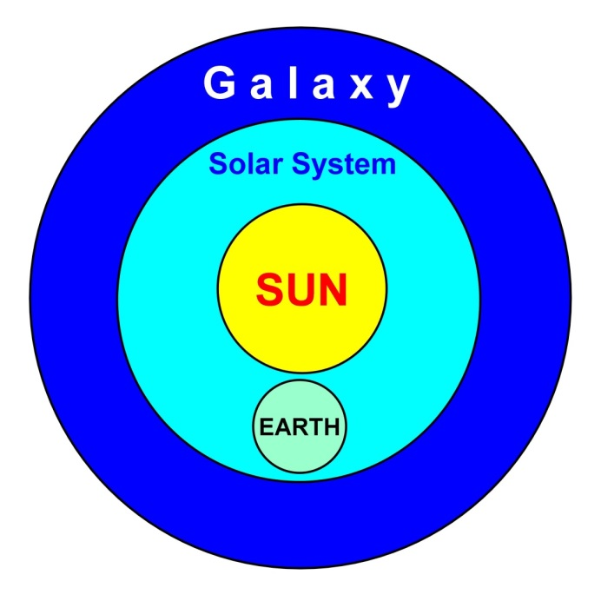

Let us see figure 5 again. In a space that is within the Galaxy but outside the solar system, the Soul-Energy is average as compared with the Galaxy as a whole. But in a space that is inside the solar system, the Soul-Energy is stronger than the average because the space is closer to the Sun. If the Soul-Energy is strong, the speed of light slows down. Thus, in the space inside the solar system, the speed of light is 300,000 kilometers per second. So the speed of light is faster than 300,000 kilometers per second in the space outside the solar system. On the other hand, in a space between two Galaxies, the Soul-Energy is much weaker, so the light can travel much faster than 300,000 kilometers per second. Light can travel even if there is no Soul-Energy at all. To be exact, light is the energy that can travel without any medium and the light has the property of wave. If there is no Soul-Energy at all in vacuum space, the light can travel much faster than 300,000 kilometers per second. In that case, the light can accelerate limitlessly. So, for example, the light can travel our Universe within few years. If we think like this, we can understand the essence of the force of inertia. In the force of inertia, for example, a car accelerates or decelerates gradually. For example, in a second, a car cannot reach the speed of 200 kilometers per hour. When a car that is running at 200 kilometers per hour stops, it cannot stop instantaneously. These things are due to the force of inertia. We think this is a natural phenomenon. I think this force of inertia is due to the power of Soul-Energy. So in a space where there is no Soul-Energy at all, there is no force of inertia. So spaceship can accelerate beyond the light speed instantaneously and stop instantaneously. Namely, this is the warp travel. Then, is there space where there is no Soul-Energy? It is the Spirit World. The warp travel and the time machine are possible by entering the Spirit World and returning to our real world. The theory of time machine will be explained later. I think that our real world is a small part of Spirit World. Spirit World exists surrounding our real world. In the Spirit World, there are many souls and so it is filled with energy, but there is no Soul-Energy that has the force of gravity and inertia. So souls can travel everywhere in the Spirit World instantaneously.
Here, let us think about the law of gravity. The equation of gravitational force is as follows:

F: magnitude of gravitational force between two point masses
G: gravitational constant
m₁: mass of the first point mass
m₂: mass of the second point mass
r: distance between the two point masses

NOTE: Point mass is the theoretical point. It is the matter or object infinitely small.

As shown in the equation above, the gravitational force weakens according to the distance between two point masses. If the distance increases two times, the force becomes one-fourth. If the distance increases three times, the force becomes one-ninth. This relation between the distance and the gravitational force is necessary to understand the phenomenon of constant speed of light.
As shown in figure 1, for the three objects, the speed of light from the light source to each object is the same whether or not three objects are moving. Namely, for the three objects, the light from the light source comes at the same speed. On the other hand, the speed of light varies according to strength and property of Soul-Energy. The strength of Soul-Energy weakens like the formula F=Gm₁m₂ /r². To be exact, m₁ and m₂ are the theoretical point masses, but objects in figure 1 are not the point masses. But the essence is the same. For example, if the distance between two objects become two times, the Soul-Energy becomes one-fourth. So if the distance is 1,000 meters and it narrows to 1 meter, the distance becomes one 1,000th. Then, the Soul-Energy increases by 1,000 × 1,000 = 1,000,000 times. This is a rough calculation because two objects are not the point masses. But we can understand that the Soul-Energy is very strong at the point very close to the object. We can see this situation in figure 6.

Figure 6. Soul-Energy

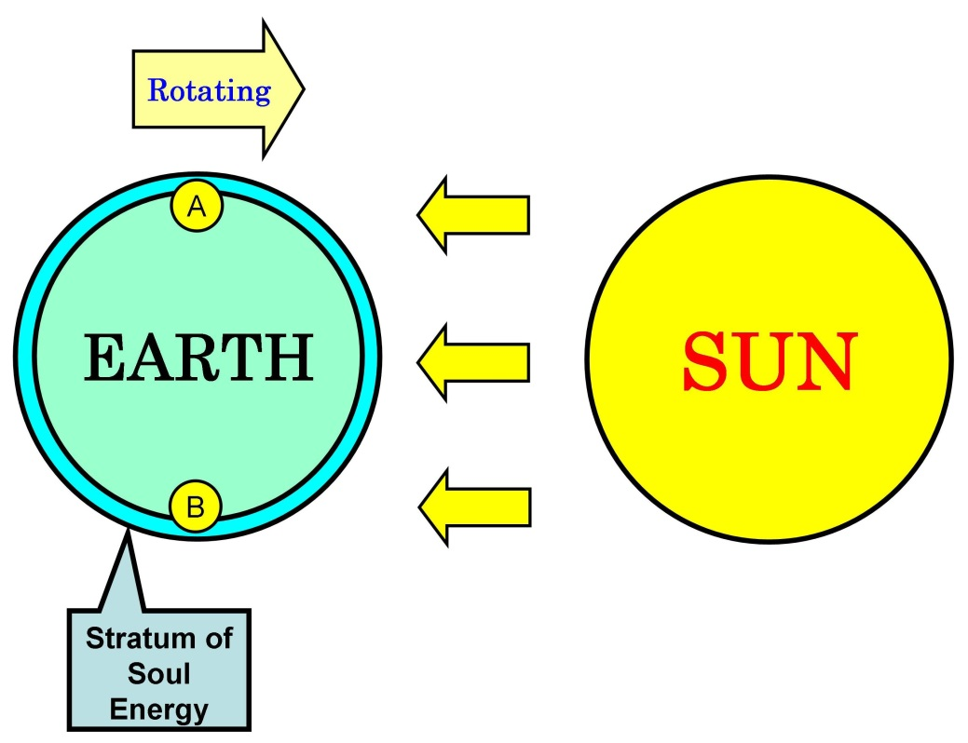

In the figure, Earth is revolving around the Sun, and at the same time, it is rotating. There is a stratum or layer of Soul-Energy around Earth. As already shown, strength of Soul-Energy weakens as the formula F=Gm₁m₂ /r² shows it. So the Soul-Energy weakens depending on the distance from Earth. Within the stratum shown in the figure, the Soul-Energy has certain strength and property. Earth is rotating and the speed of surface of Earth is about 460 meters per second on the equator. So, theoretically, the speed of light from the Sun at point A is faster than the speed of light at point B. But actually the speed is same. Einstein’s theory of relativity can explain this phenomenon by thinking that time is relative. But if we think that the stratum of Soul-Energy functions like the glass shown in figure 3, we can understand why the speed is the same. The speed of light depends on strength and property of Soul-Energy, and stratum of Soul-Energy is moving along with the surface of Earth. For the people on the point A, they are approaching the Sun. So, according to common sense, the speed of light from the Sun is higher than the ordinary speed. On the other hand, for the people on the point B, they are going away from the Sun. So, the speed must be lower. On the other hand, on the point A, the stratum of Soul-Energy is moving against the light from the Sun. So, the speed of light is slowed down in proportion to the speed of rotation of Earth. On the other hand, on the point B, the Soul-Energy is moving following the light from the Sun. So, the speed of light is accelerated. So for people on the point A and the point B on Earth, the light comes from Sun at the same speed. Then, how much is the thickness of the stratum that is necessary to decide the speed of light? I think, for example, if the stratum has the thickness of only one millimeter, it is enough to decide the speed of light. Soul-Energy is very strong at the point close to matter that has the Soul-Energy. So it is very strong on the surface of Earth and at the point close to equipment that measures the speed of light. So on the surface of Earth or at the point near the equipment, the speed of light is the same. Thus, the speed of light varies according to strength and property of Soul-Energy.
Then, let us consider some phenomena that can be explained by Einstein’s theory. As already written, some parts of Einstein’s theory of relativity have been scientifically verified. Here, three examples are introduced. First example is “muon,” a particle that emerges from cosmic rays, second example is atomic clock in satellite of GPS (global positioning system), and third example is atomic clocks on two different points on Earth. With regard to the muon, the muon emerges when cosmic rays that came from outer space collides with the atmosphere of Earth. The life of this particle is very short. The average life is only two-millionths of a second. So it can travel about 660 meters even if it travels at the light speed. But it reaches the surface of Earth from the height of 10 and several thousand meters above the surface of Earth. It is thought that this phenomenon is due to the relativity of time. Namely, for observers on Earth, it looks like that the time delayed. Second example is atomic clock in satellite of GPS. GPS shows us our exact position on the Earth. So we can know the position of our car by this system. It uses four satellites in the space. So if the speed of time on Earth and the speed of time in the satellites are different, GPS cannot calculate the exact position. This really happens. Namely, atomic clock is installed on each satellite and this clock is very accurate when it is on Earth. But when the satellite is in orbit in space, atomic clock loses its accuracy. So time is corrected according to the theory of relativity of Einstein. First and second examples are found in encyclopedia and various Websites on the Internet. Third example is written in a book of Wolfgang Rindler. He is a professor of physics at the University of Texas, USA. He writes:

Owing to this effect, the US atomic standard clocks kept since 1969 at the National Bureau of Standards at Boulder, Colorado, at an altitude of 5400 ft, as part of the International Atomic Time network, gain about five microseconds each year relative to similar clocks kept at the Royal Greenwich Observatory, England, at an altitude of only 80 ft. Since both sets of clocks are intrinsically accurate to one-tenth of microsecond per year, the effect is observable and is one of several that must be corrected for.

It is said that these examples verify that the Einstein’s theory of relativity is correct.
Thus, Einstein’s theory of relativity has been verified by some facts. But I have quite a different idea on these phenomena. Let us suppose:

1. There is World 1 where there is a candle and clock.
2. There is World 2 where there is a candle and clock.
3. There is a clock outside the World 1 and World 2. The world outside the World 1 and the World 2 is our world.

The difference between World 1 and 2 is the speed of reaction of matter. The speed of reaction is different due to the difference of strength and property of Soul-Energy. Then what is the reaction of matter? It is shown in figure 7.

Figure 7. Wave

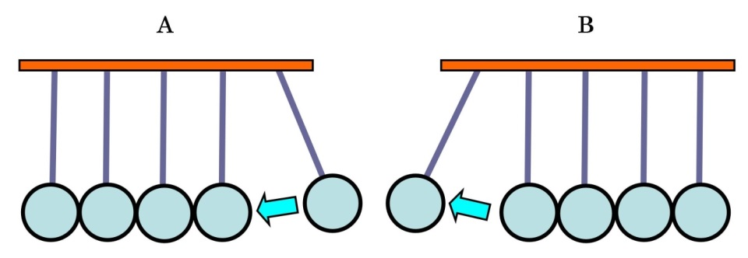

Figure 7 shows five metal or glass balls that are hung from ceiling. As shown in the figure A, if a ball of right edge is pulled up and released, it hits a stationary ball which is at the right edge. Then ball at the left edge moves as shown in the figure B. If two balls are pulled up and released, they hit the stationary balls and then two balls move. If three balls are pulled up and released, three balls move. In this phenomenon, energy moves from the right ball to the left ball. But the ball does not move along with the energy. Same type of phenomenon goes on at the atom level. For example, when a candle burns out, it is a phenomenon of oxidization. I think that the oxidization goes on as shown in figure 7. Now, let us return to the World 1 and 2. In the World 1, there is a clock and a candle. In the World 2 also, there is a clock and a candle. Outside the World 1 and 2, namely in our world, there is a clock. Thus, there are two worlds with clock and candle respectively and our world with clock. In the World 1, the speed of reaction is 1, and in the World 2, the speed of reaction is 2. The speed of reaction depends on strength and property of Soul-Energy in each world. An experiment to fire the candle at the same time in each world is conducted. The result is as follows. In the World 1, where the speed of reaction is 1, the candle burns out after 1 hour according to the clock in the World 1. In the World 2, where the speed of reaction is 2, the candle burns out after 1 hour according to the clock in the World 2. But according to the clock outside the World 1 and 2, the candle in the World 1 burns out after 4 hours, and the candle in the World 2 burns out after 2 hours. Like this, if the speed of reaction changes, the speed of movement of everything changes. So if we are in the World 1, we will see that the candle burns out after an hour. And if we are in the World 2, we will see that the candle burns out after 1 hour. Then, don’t we feel that the candle in the World 1 burns longer than the candle in the World 2? I think that soul has no sense of time. For example, let us suppose we experienced a big earthquake. After ten years, without a record, we cannot exactly remember whether it was nine years ago or ten years ago or eleven years ago. But we can know it if we read the record on the earthquake. Like this, we do not feel that the candle in the World 1 burns longer than the candle in the World 2. Thus, soul has no sense of time. Under certain condition, the speed of reaction of matter is different and so it looks like that the speed of time is different. Another example is refrigerator. As we know, foods do not spoil rapidly in the refrigerator. This is because the speed of reaction of matter is slow in the refrigerator. Needless to say, Soul-Energy is same inside and outside refrigerator. The difference is the temperature. The temperature is low in refrigerator. So energy goes out from object such as meat. So, the reaction of matter that composes meat becomes slow. So, the meats get spoiled slowly. Thus, there are some causes that affect the speed of reaction of matter. The speed of time is the result, not the cause. Thus, the time does not exist in a true sense or in a sense of Einstein’s theory of relativity. We can know the time by clock. Soul has no sense of time. Needless to say, this thought is my imagination. There is no scientific evidence.
If we think like this, we can explain the phenomenon of muon, that of atomic clock in satellite of GPS, and that of atomic clocks on different places on Earth. With regard to muon, it can be produced artificially. The average life of muon is very short. So it can travel only 660 meters even if it travels at the light speed. Also muon emerges when cosmic ray collides with atmosphere of Earth. In this case, condition is special because the cosmic ray comes from the outer space and, near the Earth, the gravity and the Soul-Energy of Earth become drastically stronger. Under this special condition, the speed of reaction of matter slows down. So muon can reach the surface of Earth from the height of ten and several thousand meters. With regard to atomic clock in satellite, it stays in the space far from Earth, so the gravity, the magnetic force, the Soul-Energy, etc., are different from those on Earth. So the speed of reaction of matter is different and so the speed of clock is different between the satellites and Earth. So the time of clock must be corrected. Incidentally, in this situation, the speed of light is also different. At the space where the satellites are staying, the Soul-Energy is weaker than on Earth, so the speed is higher. Lastly, with regard to atomic clocks on different places on Earth, the altitude is different and so the strength and property of Soul-Energy is different. Therefore, the speed of reaction of matter at the atom level is different. So the clock at the higher altitude moves faster than the clock at the lower altitude.
In cases of muon and atomic clock in satellite, muon and Earth are affecting each other and also satellite and Earth are affecting each other. But Earth is very huge as compared with muon and satellite. So it can be said that Earth is not affected. Einstein thought that matter distorts the space-time around the matter and this is the cause of gravity. I think that matter has the power of gravity. The power of gravity comes from power of soul because matter has been formed from soul. The power of gravity is an element of the Seoul-Energy.
I wrote, in my book Soul Federation, as follows.

1. Soul can keep important memories, talent, religious mind, etc., even after reincarnation.
2. Soul can create life.
3. Soul can control the body of life.
4. Soul can make life evolve by affecting the arrangement of four bases of DNA.
5. Soul can affect the reincarnation of other souls. So the reincarnation of each soul is affected by other souls.

Soul has such power and can change into energy and matter. If arrangement of bases of DNA is accidental, no life can emerge. This is because the number of arrangement of bases of DNA reaches the astronomical figures. If we consider the history of evolution, the number of lives such as fish, bird, mammal, etc., has been insufficient to achieve evolution accidentally. Namely, so far, many lives such as fish, birds, mammals, etc., have been born on the Earth. On the other hand, the number of arrangement of bases of DNA reaches astronomical figure. So, necessary arrangement of bases of DNA cannot be accidentally achieved by the lives that have been born so far. So it is impossible for the evolution to be achieved by the accidental mutation. Thus soul has the power to make necessary arrangement of bases of DNA for evolution. If we think like this, we can think that structure of Universe is affected by souls or God. Souls in the state of matter can affect the structure of Universe. Needless to say, souls in the state of matter cannot think like us human. But they instinctively remember important things. This instinctive memory or mind can affect the structure of Universe. Matter can do this by Soul-Energy, which includes gravity. No star and planet are formed without the gravity. Our Earth was formed about 4 billion and 600 million years ago. Since then, Earth has been revolving around the Sun. Can such thing happen accidentally? Why doesn’t Earth drop into Sun? So far, many satellites were launched. Some of them orbited Earth, and some of them went to the orbit round other planets or went farther away. As for the satellites in the orbit round Earth, their orbit falls due to very thin air. And so the satellites fall to Earth within several years to tens of years. As for the satellites in the orbit outside the orbit round Earth, their speed falls and they are pulled back by the gravity of Sun. With regard to this case, it is said that the mass of Earth is very heavy, but the mass of satellite is light, so satellite is affected by other objects easily, and so the speed of satellite falls easily. But, in case of Earth, many meteors collided with Earth. We can know this by seeing the craters on Moon. Those meteors must have affected the orbit of Earth and Moon. But, still, Earth and Moon are orbiting the Sun. I think that these phenomena are possible by the help of souls or God. I think that very far matters in our Galaxy and other Galaxies are affecting the orbit of the Earth round the Sun. For example, Dark Energy and Dark Matter are directly and indirectly affecting the solar system. These things enable Earth to stay in the orbit round the Sun. These things are due to the will of souls or God. Souls or God make Earth stay in the orbit round the Sun in order to maintain the environment for life on Earth. I think that the life and the Universe are the products of will of souls or God. In other words, the life and the Universe are the message of soul or God. As written already, there are three states of soul. Three states of soul are soul, energy, and matter. Soul, energy, and matter are always trying to create life. Structure of present Universe is the product of will of souls or God. Energy and matter can affect the structure of Universe. And so energy and matter are trying to make the environment where life can emerge. So structure of Universe is the will and the message of souls or God. Soul can create life and can make the life evolve by affecting the arrangement of bases of DNA. Similarly, our Universe is affected by the will of souls or God. Souls or God is trying to keep our Earth in the orbit round the Sun by the power of Soul-Energy or the power of God. In a word, everything in Universe is necessary to keep our Earth in the orbit round the Sun. For example, a star that is tens of thousands light-years away from Earth may be necessary for Earth to stay in the orbit round the Sun. With regard to satellites, they were not made by soul, energy, and matter. They were made by human. So soul, energy, and matter do not help satellites to stay in the orbit. Thus, soul has the power to make the necessary arrangement of bases of DNA. If this power is combined, it can become the power to make Universe and to maintain Earth in the orbit round the Sun. Fundamentally, souls or God made Universe to make inhabitable planets like Earth.
By the way, I sometimes wrote “souls or God” and sometimes wrote “soul, energy, and matter.” Distinction of these things is not clear for me. So I used different words, but I wanted to mention the same thing.
When I think that space is filled with the Soul-Energy, I imagine the water in the sea. In the sea, the water looks as if it were staying at a place. But there are many streams of water in the sea and there are shallow places and deep places. Like this, in the space also, there are spaces where the Soul-Energy is strong and the spaces where the Soul-Energy is weak. So the essence of Dark Matter and Dark Energy may be the Soul-Energy. Also Black Hole may be such thing.
As was already written, I think that in the Universe, there are Soul-Energies from numerous directions. The directions are numerous so the Soul-Energies neutralize each other. So Universe is filled with energy, but it is in the state of zero gravity. Where the space is filled with energy, the speed of light and object is limited by this energy. Inside the solar system, the light can travel at 300,000 kilometers per second. At the space where there is no Soul-Energy or the Soul-Energy is weak, the light can travel faster than 300,000 kilometers per second. This is because the light itself is a kind of energy and has the power to travel. If we can arrange the direction of Soul-Energy, we can get the superpower. Namely, if the direction of Soul-Energy is arranged to only one direction, it will be a superpower. This power can be a power of warp travel in space. Spaceship using this power can travel space at the speed faster than light. Power of flying saucer may be this power, though it is not sure that flying saucer really exists. If this is achieved, this is a great invention. Then, when and how will it be invented? I think it will be invented accidentally. It is just like the nuclear explosion. I think, the nuclear explosion occurred when someone was conducting an experiment of enriching radioactive substances on a planet other than Earth. The planet became uninhabitable or was destroyed. And so a soul came to the Earth and brought the instinctive memory of nuclear explosion. Or if the method of arrangement of direction of Soul-Energy has already been invented on some other planets, soul will bring the instinctive memory on it. Furthermore, another thought is possible. As already written, there is no force of inertia where there is no Soul-Energy. In the space where there is no force of inertia, we can accelerate beyond the light speed instantaneously and stop instantaneously. So if we can adjust the direction of Soul-Energy, we can make a tunnel of space where there is no Soul-Energy. In that tunnel, the warp travel is possible. But if we enter the space where there is no Soul-Energy, the speed of reaction of matter at the atom level may be very fast. That means we get old very fast. Thus new problems also will emerge.
With regard to the time of reaction of matter, as already written, the speed of time depends on the speed of reaction of matter. To be exact, there is no time in a true sense or in a sense of Einstein’s theory of relativity. Time is shown by clock. So if two persons of same age live in different worlds, one can get old faster than another. If the warp travel becomes possible in the future, this may happen. Let us suppose that there are two persons of same age. One person lives on the Planet-A, and another person lives on the Planet-B. Soul-Energy is very different on two planets and so the speed of reaction is very different. If these two persons meet after thirty years, it is possible that one is still young and another is very old. Needless to say, here, thirty years is the time on Earth. So if we can adjust the speed of reaction, we can make a time machine.
I have imagined another thing. According to Bible, Adam lived for 930 years and Noah lived for 950 years. Noah is one of Adam’s descendants. Also many Adam’s descendants lived for about 900 years. This is incredible for us. But in Japan also, there is such records. The oldest book in Japan is Kojiki (records of ancient matters) written in 712. It contains myths. So contents are not recognized as historical facts. According to it, some emperors lived more than 120 years. This is also incredible. But if the stories in Bible and Kojiki are concerned with the historical facts on other planets, it is not strange. Let us suppose that souls of Christians came from the Planet-Christian and the souls of Japanese came from the Planet-Japanese. As for the Planet-Christian, the period of revolution of planet is much shorter than that of Earth. Namely, the Planet-Christian was revolving around the Sun much faster than Earth. Or due to strength or property of Soul-Energy, the speed of reaction of matter is much slower on the Planet-Christian than on Earth. If this idea is correct, long life of Adam and Noah can be explained. This can be said for the records in Kojiki also. For example, if the period of revolution of Planet-Christian was one month on the basis of the time on Earth, Adam’s life was 930 / 12 = 77.5. This is not strange. And also, if the speed of reaction of matter on the Planet-Christian is one-tenth of Earth, Adam’s age was not strange. Namely, the speed of reaction of matter was slow, so the speed of getting old was slow. It is possible that speed of reaction of matter was very slow in the earlier age of history of Universe, but later it sped up to the present speed. So when there was the Planet-Christian, the speed of reaction of matter might have been very slow. Souls that came from the Planet-Christian to the Earth instinctively remembered the memory on the Planet-Christian and the Bible was written on the basis of this instinctive memory. Or the speed of reaction of matter on Earth might have been slow before. This is possible if the Soul-Energy was stronger before. There is another cause of the slow speed of reaction of matter. If the Earth or the solar system as a whole is moving in the field of Soul-Energy at high speed, the speed of reaction of matter slows down. This is mentioned later.
Furthermore, there is an interesting story in the Bible. In the Bible, there is a story:

On the very same day Noah with his sons, Shem and Ham and Japheth, and Noah’s wife and the three wives of his sons entered the ark, they and every wild animal of every kind, and all domestic animals of every kind, and every creeping thing that creeps on the earth, and every bird of every kind—every bird, every winged creature.

Noah followed the command of God and made an ark to save all lives from flood. He took all kinds of animals into the ark. In the above story, “creeping thing that creeps on the earth” is very interesting. What is creeping thing? This creeping thing appears many times in the story of Noah’s ark. There is another strange point in the story of Noah. Namely, there is no insect in the story of Noah. From this story, I imagine a story. On the Planet-Christian, there was no insect. If there had been insects on the Planet-Christian, the creeping things that creep on Earth would have been eaten and annihilated by insects. On Earth also, there are many creeping creatures. But they do not creep on the Earth. They are in soil. If there were no insect on Earth, the creeping creatures in soil would be able to live on the ground. The ecosystem of the Planet-Christian was different from that of Earth. If there was no insect on the Planet-Christian, it means that the ecosystem of Planet-Christian was more primitive than that of Earth. From these things, I imagine another story. Area of land of Planet-Christian was very small as compared with that of Earth. For example, the land on the Planet-Christian was an island smaller than Japan. The highest place of island was very low. For example, the highest altitude was lower than one hundred meters. One day, a huge tsunami hit the island and it sank underwater. Only people and other lives on ships could survive. Later, souls on the Planet-Christian came to Earth. The incident on the Planet-Christian became the origin of the story of Noah’s ark. Or another story is possible. There is a legend of the continent of Mu. It is said that Mu sank into the ocean. I cannot imagine whether Mu was on the Planet-Christian or on Earth. This legend does not contradict with the story of Noah’s ark.
Then, what about soul? I think that soul can travel Universe at the light speed. Soul-Energy affects the speed of travel of soul. To be exact, essence of Soul-Energy is the power of soul and so the speed of soul is affected by the Soul-Energy. This happens when soul is in our real world. When soul is in the Spirit World, there is no Soul-Energy that has the force of gravity and inertia and other forces. So soul can travel beyond the light speed. For example, soul can travel the distance of billions of light-years within one year. Our real world is a small part of Spirit World. Our real world was made by souls. Souls have a common desire to make a heaven. So some of souls became energy and matter in order to make our real world. Souls made our real world and are trying to make it a heaven. So, making our real world a heaven is the mission from God. Making our world a battlefield is not the mission.
With regard to particles such as electron, muon, neutrino, etc., I imagine the essence of these particles as follows. Electron, muon, neutrino are called elementary particles. The elementary particle has no substructure. Namely, it is not made up of smaller particles. For example, atom is made up of electron, proton, and neutron. So atom is not an elementary particle. When the atom was thought to be the smallest particle of matter, it was classified as an elementary particle. The substructure of elementary particles such as electron, muon, neutrino, etc., may be known in the future. In that case, electron, muon, neutrino, etc., are not classified as elementary particle. It is said that electron, muon, neutrino, etc., travel at the speed close to the light speed. But I think that these particles are the products of energy and do not travel. It is shown in figure 8.

Figure 8. Soul-Energy and Particle

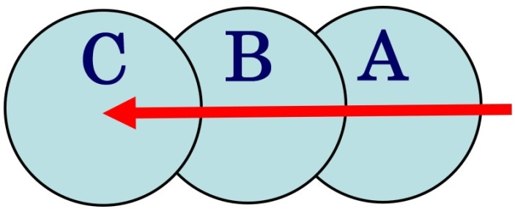

The arrow shows that energy is moving from the right side to the left side. The energy is moving in the field of Soul-Energy. As already written, energy can change into matter. In figure 8, Soul-Energy changes into particle A when the energy passes. If the energy moves ahead, particle A disappears because it returns into Soul-Energy and particle B appears. If the energy moves ahead farther, particle C appears and particle B disappears. This is the essence of particle. Particles do not travel. The kind of particle depends on the property of Soul-Energy and the energy that moves. Namely, electron or muon or neutrino emerges depending on the property of Soul-Energy and the property of moving energy.
With regard to the time, we can explain it by the thought of Soul-Energy. The speed of reaction of matter at the atom level depends on strength and property of Soul-Energy. If the Soul-Energy is strong, the speed is slow. But even if strength and property of Soul-Energy is constant, the speed of reaction of matter can change if an object moves in the field of Soul-Energy. This thought does not contradict with Einstein’s theory of relativity. Einstein insisted that when an object moves at the light speed, the time stops. He thought that the time is relative. But this phenomenon can be explained by thinking that the speed of reaction of matter at the atom level varies when an object moves in the field of Soul-Energy. There is the Andromeda Galaxy, which is about 2 million and 500 thousand light-years away from Earth. Let us suppose that we travel to the Andromeda Galaxy and return to Earth by a spaceship that travels at the light speed. We will return the Earth about 5 million years later. But according to the theory of relativity, for crew on the spaceship, it can be a few days. If we think the time is relative, this is possible. But we can think in another way. Namely, if a spaceship travels at the light speed in the field of Soul-Energy, the speed of reaction of matter at the atom level falls and so clock on the spaceship also is delayed. The theory of relativity says that when an object is moving at the light speed, the time stops. I think that phenomena of this type occurred on a planet where Einstein was living in his former human life. Needless to say, the planet was not the Earth and the planet was destroyed or became uninhabitable and so Einstein’s soul had to travel the Universe and reached the Earth. He remembered the phenomena instinctively and made the theory of relativity to explain them. If we think like this, we can accept the age of Adam and Noah in the Bible. Adam and Noah lived more than 900 years. This is unacceptable for us. But if their planet, Planet-Christian, was moving in the field of Soul-Energy at a very high speed, the speed of reaction of matter at the atom level might have been very slow. If so, the age of Adam and Noah is not strange.
Thus, according to the theory of relativity, if an object moves at the light speed, time stops. Einstein explained this by thinking that time is relative. But I think as follows. Figure 9 shows the relation between the movement of object and the movement of energy within the object in the field of Soul-Energy. In the figure, ellipse means an object. Objects are in the field of Soul-Energy. The arrow shows the movement of energy. The energy starts to move from the right edge of the arrow. The arrow shows that the energy has moved from the right edge to the top point of arrow. We can think that matter reacts after the energy has moved within the matter. For example, a candle burns after the energy has moved in the candle. This can be said for everything. The speed of movement of energy is constant on the basis of the field of Soul-Energy. Or, the speed is constant as compared with the field of Soul-Energy. But, the field of Soul-Energy has no fixed point that can be a criterion of the position. So we should think that the criterion is our Galaxy. If we think that the Galaxy is a criterion, we can distinguish a moving object from a staying object. This is acceptable because the Soul-Energy is generated by the energy of the matters that form the Galaxy. Thus we can know our position in the field of Soul-Energy by measuring our position in the Galaxy. In the Figure 9, the upper object is staying at a point and the lower object is moving to the left at a speed close to the light. Namely, in case of the lower object, the object has moved from position A to position B. The arrow shows the movement of energy. In the upper object, the energy moved as shown in the figure. Namely, the energy moved from the right edge to the top of the arrow. So, in the upper object, the energy has moved from the right edge of the object to the left edge of the object. So, something has changed in the object. For example, if the upper object is human, it has grown or got old to some extent. In case of the lower object, it is moving at a high speed close to the light. The energy in the lower object is moving at a speed same as the speed of the energy in the upper object. Needless to say, the speed of energy in the upper object and that of the lower object is same as compared with the field of Soul-Energy. But in case of lower object, it has moved at a speed close to the light. So the position of the energy in the lower object has not moved like the case of the upper object. Namely, the energy is around the center of the lower object. So, the reaction of matter was slow as compared with the upper object. If the lower object is a human, she or he has not grown or has not got old like the case of the upper object. Thus reaction or change of matter needs the movement of energy.

Figure 9. Field of Soul-Energy
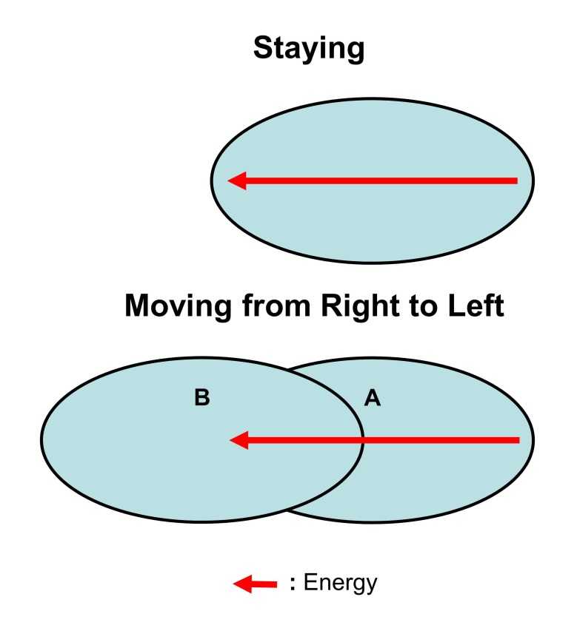
This thought is shown in more detail in the Figure 10. In the Figure 10 also, an ellipse means an object. Objects are in the field of Soul-Energy. In the figure, there are three cases. Let us call the three cases of object the first case, the second case, and the third case. In the first case, object is staying at one place. In the second case, object is moving from the right side A to the left sight B. In the third case, object is moving from the left side A to the right side B. Needless to say, the movement of objects means that the objects move as compared with the field of Soul-Energy. The speed of movement of object is lower than the light speed. In this situation, space is filled with Soul-Energy. I think that reaction of matter occurs when energy moves from one point to another point in object.

Figure 10. Moving in the Soul-Energy

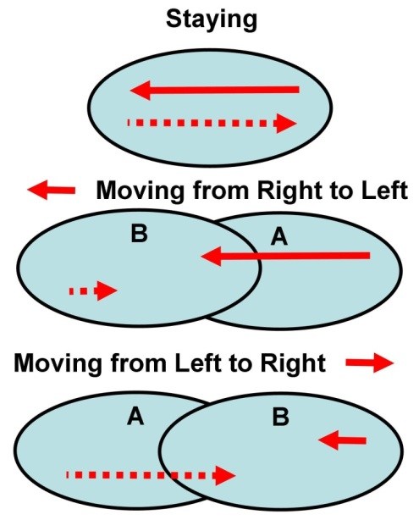

: Front Energy
: Shadow Energy

Here, reaction means the reactions such as flow of electric current, oxidization such as burning of candle, conduction of heat, transmission of light or radio wave, etc. Electric current flows in circuit at the speed close to the light speed while burning of candle is very slow. But energy is moving from a point to another point in these reactions. I think that movement of energy is not one. Namely, there are Front Energy and Shadow Energy. Names of energy are provisional. I could not think out better names. In case of electric current, electric current flows from plus pole and electron flows from minus pole. Electric current is Front Energy, and electron is Shadow Energy. Thus, Front Energy and Shadow Energy move in the opposite direction. Usually, we think that energy moves in only one direction. For example, in the figure 7, kinetic energy moves from the right side to the left side. This is the movement of Front Energy. Shadow Energy moves in the opposite direction. Usually, we think about Front Energy only. In case of light also, we usually think about only one direction. Namely, we usually think about the direction from the light source to the object only. This is Front Energy. But Shadow Energy moves in the opposite direction. Like this, I think, Front Energy and Shadow Energy move in the opposite direction each other. There are many symmetrical phenomena or matters like this in our world. For example, there are plus and minus in electric current, acidity and alkalinity in many substances, female and male in mostly every life, matter and antimatter, etc. Similarly, there are Front Energy and Shadow Energy. When both energies have moved in the opposite direction, reaction of matter occurs. This is shown in three cases in figure 10. For example, in the first case, it can be the flow of electric current. When electric current flows, electric current flows from the plus pole and electron flows from the minus pole. To be exact, as already mentioned, there is no flow of particle like electron. There is a movement of energy. It is shown in figure 8. As already written, electric current is Front Energy, and electron is Shadow Energy. Needless to say, this is my imagination without scientific evidence. If we think like this, we can explain why time delays or stops when an object moves at certain speed or at the light speed. To be exact, time does not delay but reaction of matter at the atom level delays. Namely, there is no time in a true sense or in a sense of Einstein’s theory of relativity. We cannot know time by our own ability of senses but we can know time by clock. Time is the result, not the cause. In object, the maximum speed of Front Energy and Shadow Energy is close to the light speed. The light speed depends on strength and property of Soul-Energy. On Earth, the light speed is 300,000 kilometers per second. Front Energy and Shadow Energy in object can move at about 300,000 kilometers per second at the maximum because the object is in the field of Soul-Energy. Here, we assume that Front Energy and Shadow Energy move in object at the light speed. In the first case, object is staying at one place and reaction in the object occurs when Front Energy and Shadow Energy have moved in the opposite direction. On the other hand, in the second case, object is moving from the right side A to the left side B. When the object moves from A to B, Front Energy moves the distance shown in the figure. This distance is same as the distance in the first case in which object is staying. This is because the maximum speed of Front Energy depends on strength and property of Soul-Energy. Namely, the distance of movement is constant on the basis of the field of Soul-Energy. But, in the object, Shadow Energy moves much shorter distance as shown in the figure. This is because object moves from A to B and so the position of Front Energy in object changes to the extent shown in the figure. Namely, the distance of movement of Front Energy is same as the distance in the first case, but, in the second case, the object moves and so the position of Front Energy in object moves to the extent shown in the figure. So, the position of Shadow Energy in object moves corresponding to it. In this case, the speed of reaction of matter at the atom level slows down. In the third case, object is moving from the left side A to the right side B. In this case, Shadow Energy moves as shown in the figure. The distance is same as that in the first case. But, Front Energy moves to the extent shown in the figure. This is because the position of Shadow Energy in object moves to the extent shown in the figure and so Front Energy can move corresponding to Shadow Energy. In the third case also, the speed of reaction of matter at the atom level slows down. When object moves vertically, mechanism is a little bit different but the essence is same. Speed of reaction slows down. Here, we do not go into the detail of it. Thus, when an object moves in the field of Soul-Energy, the speed of reaction of matter at the atom level slows down. So, it looks like that the time delayed. Here, I explained the delay of time by assuming the Front Energy and the Shadow Energy. This idea may be wrong. But, it is possible that if object moves in the field of Soul-Energy, the speed of reaction of matter at the level of atom slows down following a different process. At least, if the direction of movement of energy and object is same, the speed of movement of energy in the object may slow down. If this really happens, the speed of reaction of matter slows down. So, it looks like that the time delayed or stopped. Adam and Noah in the story of Bible lived for more than 900 years. If this thought on the Soul-Energy is correct, we can accept the age of Adam and Noah. Namely, their planet was moving in the field of Soul-Energy at the very high speed and so the speed of reaction of matter at the atom level was very low.

2. Explanation Why an Object Becomes a Line When the Object Moves at the Light Speed

Furthermore, in the Einstein's theory of relativity, it is famous that when an object moves at the speed of light, it becomes ａline. This is explained in a different way following the idea of Soul-Energy. There is some energy in an object. As shown in the Figure 11, the energy is always moving in an object.

Figure 11. Movement of Energy in an Object

Property of object changes after the movement of energy. For example, meat of animal spoils in the room temperature. This is caused after the movement of energy. We human being get old after some reactions of our body following the movement of energy in body. If the energy leaves an object, the speed of reaction of the object slows down. For example, in the refrigerator, meat does not spoil easily. This is because thermal energy leaves the meat. The energy moves to every direction as shown in the figure 11. So, if an object moves at a very high speed, a phenomenon that Einstein insists occurs. Figure 12 shows three cases. Case A shows that an object is staying at a spot. Case B shows that an object is moving at a speed half of the light. Case C shows that an object is moving mostly at the light speed.
In case A, the object is staying at a point. Here, "a point" means a point in the field of Soul-Energy. Namely it is assumed that the object is in the field of Soul-Energy. In the field of the Soul-Energy, the speed of light depends on the strength and property of Soul-Energy. So, in case A, energy can move to any direction.
In case B, the object is moving to the left at the half of light speed. In this case, the object is moving to the left in the field of Soul-Energy and so, within the object, the field of Soul-Energy is moving to the right. So, the energy moving to the left must move against the movement of the field of Soul-Energy. And so, the energy moving to the left cannot move like the case A. But the energy moving to the right can move like case A because the object is moving to the left and so the energy needs not move against the field of Soul-Energy.

Figure 11. Objects in the Field of Soul-Energy
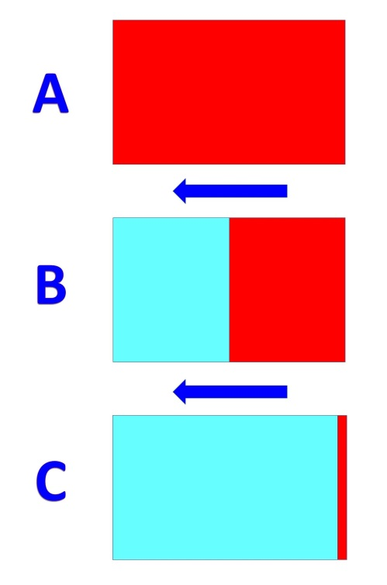

NOTE:
In the object A, there is energy in all part of object.
In the object B, there is energy in the right half the of object.
In the object C, there is energy in a part like a line.

In case C, the object is moving at the speed close to the light. Within the object, the field of the Soul-Energy is moving at the speed close to the light. The energy moving to the left must move against the movement of the field of Soul-Energy. So the energy moving to the left cannot move. But the energy moving to the right can move. So, the energy gathers at a point close to the right edge of object. Thus the energy becomes like a line. In Einstein's theory of relativity, an object that is moving at the light speed becomes a line. In the theory of this paper, the energy gathers at an area that is like a line but the object does not become a line. In the object, in an area where there is no energy, the matter does not react. Namely, it is in the situation where time stops.

3. Conclusion

Thus, we can see in a different way why the time stops and why the energy gathers in an area like a line when an object moves at the speed of light.

SELECTED BIBLIOGRAPHY

In English

American Bible Society. Holy Bible. New Revised Standard Version. New York: American Bible Society, 1989.
Rindler, Wolfgang. Relativity: Special, General, and Cosmological. 2nd ed. New York: Oxford University Press Inc., 2006: reprint ed., New York: Oxford University Press Inc., 2007.
Suzuki Toshio. Soul Federation. Bloomington: Xlibris Corporation, 2010.
Wikipedia. “Theory of Relativity”. http://en.wikipedia.org/wiki/Theory_of_relativity: Wikipedia, 2007.

In Japanese

Oono, Yasumaro, and Arei, Hiedano. Kojiki. n.p.: n.p., 712.

Toshio Suzuki, Soul Federation, (Bloomington: Xlibris Corporation, 2010).
Wikipedia, "Theory of Relativity" (http://en.wikipedia.org/wiki/Theory_of_relativity: Wikipedia, 2007).
Wolfgang Rindler, Relativity: Special, General, and Cosmological, 2nd ed. (New York: Oxford University Press Inc., 2006; reprint ed., New York: Oxford University Press Inc., 2007), 26.
Toshio Suzuki, Soul Federation, 106.
American Bible Society, Holy Bible, New Revised Standard Version (New York: American Bible Society, 1989), 4 and 8, Genesis, The Old Testament.
Yasumaro Oono and Hiedano Arei, Kojiki (n.p.: n.p., 712), Information on Kojiki was got from various Websites on the Internet.
American Bible Society, Holy Bible, 6, Genesis, The Old Testament

