U N I T S O U L

By

Toshio Suzuki

World Government Institute

© Copy Right, Toshio Suzuki, May 2016

All rights reserved.

Toshio Suzuki
World Government Institute Japan
1-158 Nakakanasugi Matsudo City, Chiba Prefecture, 270-0007, Japan
Web Site: http://www.w-g.jp/

CONTENTS

CONTENTS iii
PREFACE 1
I BASIC KNOWLEDGE 1
1. Basic Assumption 1
2. Some States of Unit Soul 2
II ACTUAL WORLD 4
1. Field of Energy 4
2. Reaction of Matter 5
III VARIOUS ASPECTS 7
1. History of Unit Soul 7
2. Evolution of Life 10
3. Reincarnation 11
IV CONCLUSION 12
SELECTED BIBLIOGRAPHY 15

PREFACE

This paper is to show the essence of the gravity. In the process to show the essence of gravity, the most basic element of this world is considered. Here, the most basic element does not mean atom or elementary particle. In this paper, I named it the Unit Soul. I used the word “Unit” because the Unit Soul is the most basic entity of this world. The Unit Souls compose the soul of human. The Unit Soul is the most basic element of matter, energy, and soul. It has no substructure. It is the origin of feeling of happiness. Unit Soul has a mind in it. Rather, it is a mind itself. We human being are composed of Unit Souls and so we feel happy or unhappy.
The Unit Soul combines together and become other entities such as matter, energy, human soul etc. There are two types of Unit Soul. Namely, one type is plus and another type is minus. This difference of plus and minus is the cause of difference of female and male of life. This Plus Unit Soul and the Minus Unit Soul attract each other. This attracting power is the cause of gravitational force.
These things are explained in this paper.

I BASIC KNOWLEDGE

1. Basic Assumption

This paper contains some new conceptions. So, some basic knowledge is necessary to understand this paper. First, I sometimes use words such as "god" or "soul". Basically, I think the god is the soul. Thus I believe in the god. In other words, soul plays the role of the god. I would like readers to remember this as basic knowledge.
This paper aims to show a new idea on the essence of this world. Thoughts in this paper have not been scientifically verified. They are results of my imagination. But, mere imagination is valuable if it is closer to the truth than conventional thoughts.

2. Some States of Unit Soul

In this paper, the most essential entity means the Unit Soul. Basic property of Unit Soul is shown in the Figure 1. There are two types of Unit Soul. We call them the Plus Unit Soul and the Minus Unit Soul. The Plus Unit Soul and the Minus Unit Soul attract each other. This power of attracting each other cannot be analyzed scientifically. It may be analyzed scientifically in the future. The Plus Unit Soul and the Minus Unit Soul combine together and form every entity in the universe. They become elementary particles such as muon or neutrino, etc. Or, they become atom of matter such as water, iron, gold etc. Or, they become energy of every type such as light, kinetic energy, thermal energy, etc. Or, they become soul. Matter, energy, soul change into other states each other as shown in the Figure 2.

Figure 1. Basic Component of Unit Soul

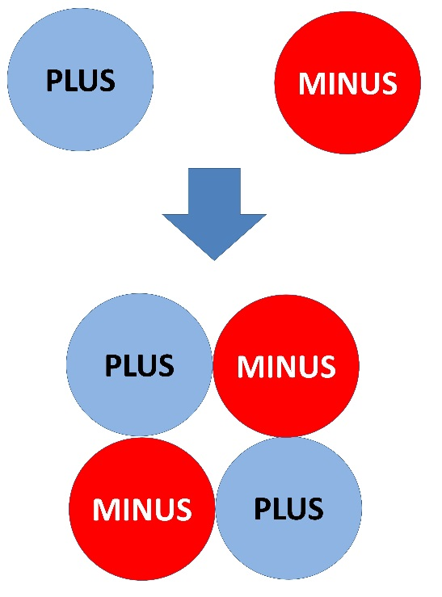

Unit Souls become solid, liquid, gas, energy, soul, etc. depending on the combination of Unit Souls. This combination decides the state of Unit Souls. As shown in the Figure 3, Unit Soul combines together in various ways. Here, only combinations of soul, light, muon, and water are shown. The Figure 4 shows the earth and the moon. Important point is that Plus Unit Soul and Minus Unit Soul attract each other. This is the origin of gravity. Because of this power of Plus Unit Soul and Minus Unit Soul, the earth and the moon attract each other. As shown in the figure, Plus Unit Soul in the earth and Minus Unit Soul in the moon attract each other. This is why earth and moon attract each other by gravity.
Unit Souls may be in a state of solid depending on the combination of Unit Souls. For example, ice is the Unit Souls in a state of solid. Some energy can pass through solid. For example, electricity can pass through many metals. Or thermal energy can pass through many
Figure 2. Transformation of Matter, Energy, and Soul

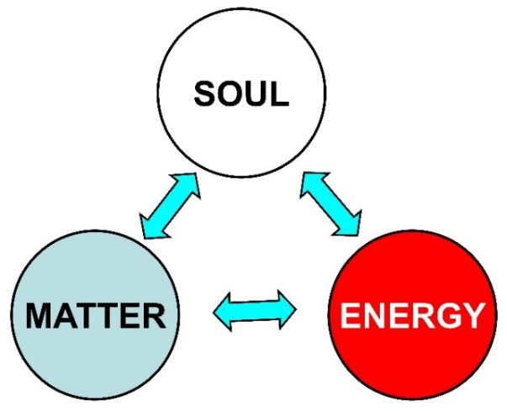

Figure 3. Combination of Unit Soul

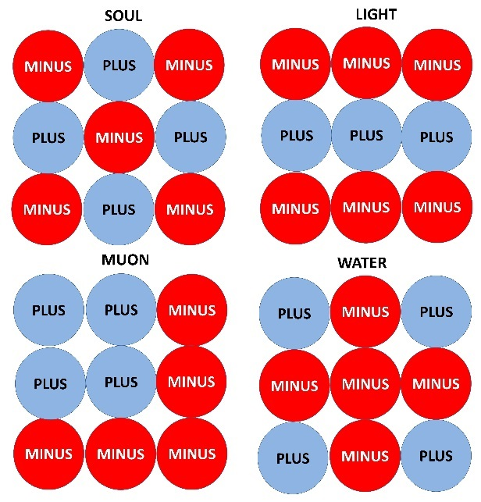

Figure 4. Origin of Gravity

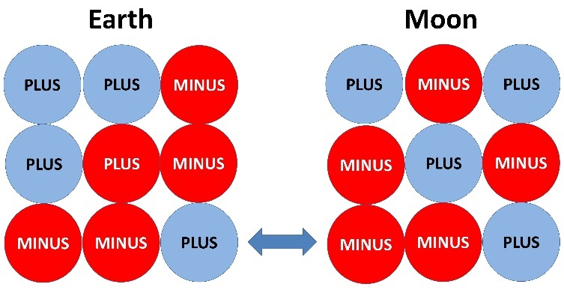

metals. Unit Souls are combined in other ways. For example, water is combined Unit Souls in the state of liquid. Some kind of energy can pass through water. Water vaporizes into water vapor. Water vapor is in the state of gas. This phenomenon happens depending on the combination of Unit Souls.
Unit Souls under certain combination can be energy. There are a lot of states in energy. The energy can be light energy, kinetic energy, thermal energy, etc. The energy passes through matter. For example, water is a kind of matter, and light can pass through water. This phenomenon happens in case of many other types of energy.
According to the theory of Einstein, matter changes into energy. This is shown by the formula:

E = mc²

E: Energy
m: mass
c: speed of light.

As shown in the formula, matter can become energy. This is a theoretical explanation of atomic bomb. This energy can pass through matters. For example, light can pass through water.
Depending on the combination of Unit Souls, Unit Souls become a soul. Each Unit Soul has mind in itself. But the mind of each Unit Soul is very weak and vague. Unit Souls have clear mind when they are combined together into a soul.

II ACTUAL WORLD

1. Field of Energy

Unit Souls in the state of matter have the gravitational force. For example, the earth is moving around the sun. This is because the sun has the gravity. This gravity forms a field of energy. Gravity of matter and other energies become a combined energy. We call it the Soul Energy. Here, other energies mean every kind of energy such as thermal energy, kinetic energy, etc. These all kinds of energy form the Soul Energy. So every matter has the Soul Energy. This Soul Energy has the gravitational force. So each Soul Energy has a direction. If the gravitational force of Soul Energy comes from some directions, the gravitational force neutralizes each other as shown in the Figure 5. In the Figure 5, there are an object and three matters that are around the object. The gravity comes from each matter. But direction of gravity is different, and each gravitational force neutralizes each other. So, at the point of the object, it is the state of no gravity. This is the situation in the outer space. Mostly everywhere in the universe, there is no gravity or the gravity is very weak. This does not mean there is no energy where there is no gravity. Everywhere in the space is filled with Soul Energy. Namely, Soul Energy forms fields of energy. Matter and energy can move in this field of energy. The speed or the velocity of energy or matter that moves in the field of Soul Energy depends on the strength and property of Soul Energy. It is said that the light moves at the speed of 300 thousand kilometers per second and this speed does not change. But, in this paper, if the strength or property of field of Soul Energy changes, the speed varies.

Figure 5. Soul Energy from Matter
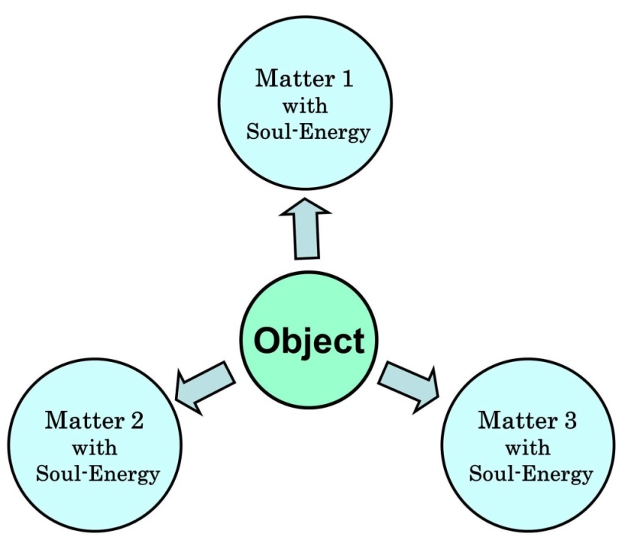

If we think like this, we can approach the truth of the gravitational force. Einstein explained that the essence of gravity is the curvature of time and space. In February 2016, it was reported that scientists detected the gravitational wave and this discovery proved the Einstein’s theory. This thought is not far from the truth. But there is a thought that is closer to the truth than this thought. It will be shown below.

2. Reaction of Matter

Here, reaction of matter is, for example, the reaction such as change from water to ice. A matter in a situation changes into another situation. In this paper, it is assumed that this phenomenon occurs because energy in the matter moves. For example, ice changes into water after moving of energy in ice. This thought is applicable to life. After life is born, it grows and dies. In this process, energy moved in the body of life in many directions. So, if the speed of movement of energy slows down, the reaction of matter takes longer time. For example, when water becomes ice, if the speed of movement of energy in the water slows down, water becomes ice taking longer time.
In case of life, same thing can happen. If the speed of movement of energy is low, the life grows slowly or gets old slowly. In case of human also, the human grows or gets old slowly. According to Bible, Adam lived for 930 years and Noah lived for 950 years. Noah, who made ark, is one of Adam’s descendants. Also many Adam’s descendants lived for about 900 years. In Japan also, there is a similar example. According to Kojiki, some emperors lived over 120 years old and also other emperors lived close to it. This is not strange if their planet is in the field of Soul Energy where the speed of movement of energy is much slower or if their planet was moving in the field of Soul Energy at the speed much higher than the earth. This will be explained in more detail later.
When an object is moving in the field of Soul Energy, the speed of reaction of matter slows down. This is shown in the Figure 6.

Figure 6. Field of Soul Energy
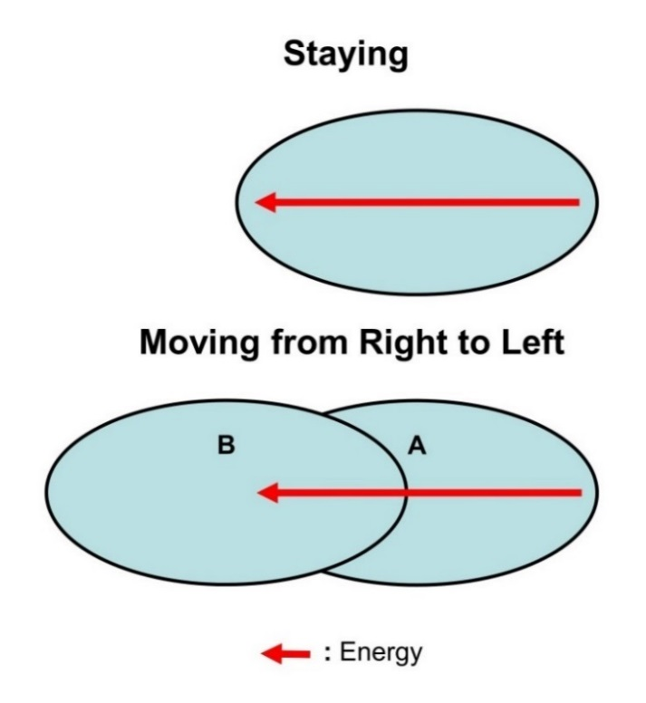
In the Figure 6, an ellipse shows an object. The objects are in the field of Soul Energy. Line with arrow mark shows the movement of energy. This means that energy moved in the object. For example, in human, energy moved and a baby grew. In the upper case, the object is staying. In the lower case, the object is moving. Here, staying or moving means that the object is staying or moving as compared with the field of Soul Energy. Needless to say, the field of energy itself is moving in the galaxy. The maximum speed of movement of light and matter depends on the strength and property of the field of Soul Energy. So, in the Figure 6, the distance of movement of energy is same. In the upper case, the energy moved from the right edge to the left edge of the object. But in the lower case, the energy moved from the right edge to the center of the object. This is because, in the lower case, the object moved. If the movement of energy is less, the reaction of matter is less. So, if the object in the Figure 6 is water, the object of upper case may become ice, but the object of lower case may remain water. This is because the movement of energy is less in the case of lower object. Thus when an object moves at a high speed, the movement of energy decreases in the object.
There is another cause of low speed of reaction of matter. When vegetable or meat is in freezer, it does not spoil soon. The reason is simple. In the freezer, the speed of movement of energy is same but the energy gets out of vegetable or meat. So Vegetable or meat does not spoil soon.

III VARIOUS ASPECTS

As written above, Unit Souls combine together, and this combination decides the situation of Unit Souls. Some Unit Souls become matter such as water. Some Unit Souls become energy such as light, thermal, kinetic energy etc. And, some Unit Souls become soul. We are human and so we have soul in our body. Here, we consider various aspects of the Unit Soul.

1. History of Unit Soul

We have seen basic feature of the Unit Soul. Let us think of the history of Unit Soul. The history explained here is a result of my imagination. Mere imagination is valuable if it is closer to the truth than conventional thoughts. We consider from the time before the Big Bang. Plus Unit Soul and Minus Unit Soul attract each other. So, in the universe, there are many points where both the Plus Unit Souls and the Minus Unit Souls have gathered. Black hole is one of them. These points cause the Big Bang when the mass reached certain level. So, there are many points that will cause the Big Bang in the future. So far, numerous Big Bang have occurred. We are living in a universe that was formed by one of those Big Bangs. Our universe is expanding with accelerating speed. This is explained using the Figure 7 below. It was thought that speed of expansion of our universe is decelerating and the universe will shrink in the future. But, the speed of expansion is accelerating. There are some thoughts that explains this phenomenon. Some people think that the acceleration of speed is due to repulsive forces. But it can be explained by the Figure 7. Our universe is formed by a Big Bang. There are some other groups of matter as shown in the figure. They are attracting matter. So matter of our universe is attracted and the speed of expansion is accelerated. The groups of matter will grow and cause a Big Bang when they reach a certain mass. This phenomenon occurs because the Plus Unit Souls and the Minus Unit Souls are attracting each other. Thus Big Bang occurs in many places in universe.

Figure 7. Big Bag Occurs Occasionally at Some Places in the Universe.

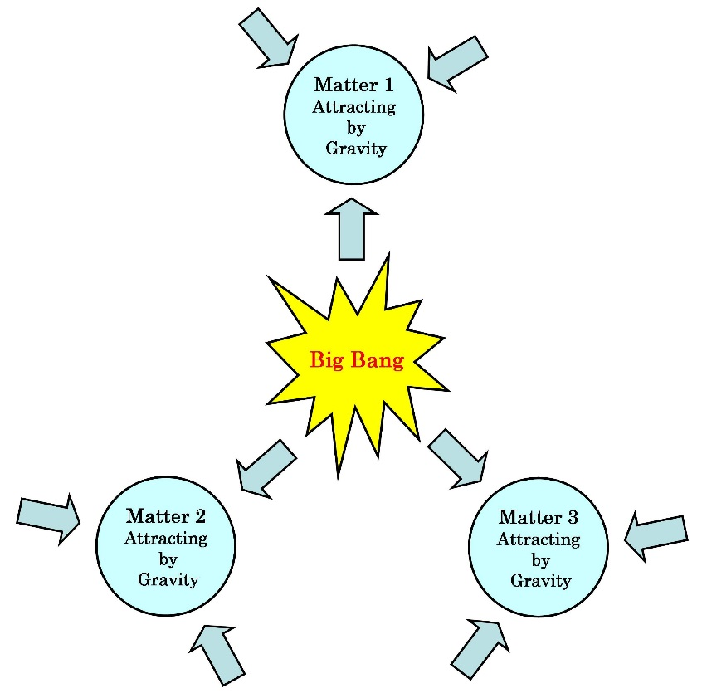

At the time of Big Bang, there is no difference of the matter, the energy, and the soul. Every entity was the Unit Souls. They are separated into the smallest unit. The smallest unit of Unit Soul is shown in the Figure 1. Namely, the Plus Unit Soul and the Minus Unit Soul are separated. As already written, Plus Unit Soul and Minus Unit Soul attract each other. This force cannot be analyzed by scientific thought. This force is the source of gravity. Each Unit Soul has a mind or instinct. Basically, they want to feel happy. So this feeling that wants to feel happy affects the force of gravity. This mind and force made the universe. This thought does not contradict with the thought that the god created the universe. Namely, Unit Soul played the role of god. Gravitational force of Unit Soul works instinctively. That instinctive force makes stars and planets. Stars and planets are not formed accidentally. They are formed following the instinctive will of Unit Souls. These stars and planets form galaxies. If a planet that is inhabitable for life is formed, Unit Souls begin to make lives. Unit Soul can combine together. Unit Souls can become matter or energy or soul according to its combination. The Unit Soul has a mind that wants to be happy. This mind decides the combination of Unit Souls. Some Unit Souls make stars and some Unit Souls make the planet. When inhabitable planet is made, at first, Unit Souls make very simple life such as bacteria. In bacteria, there are DNAs that decides the evolution of life. The combination of DNAs of bacteria is decided by the instinctive will of the Unit Souls. Like this, life evolves and reaches human being. If we think like this, we can understand why the earth revolves around the sun for a long time. The earth has been revolving around the sun for billions of years. This phenomenon cannot be explained by physics. The earth has been revolving around the sun because the will of Unit Souls have been maintaining the orbit of earth. This is like an instinct. Unit Souls want planets where they can make lives. So they are maintaining the orbit of the earth.
There is an important thing. Namely, we should consider the relation between the Einstein’s theory of relativity and the Unit Soul. Einstein insisted that the gravitational force is caused by the curvature of time and space. Recently in 2016, it is reported that the gravitational wave has been detected and so the Einstein’s theory has been verified. On the other hand, from the viewpoint of Unit Soul, it is thought that there is no time and space in a sense of Einstein’s theory. Actually, there is space in the universe. But that is just a space and that does not curve. Where there is matter, there is space. Furthermore, clock shows the passing of time, but that passing of time is just a movement of clock. In the thought of Unit Soul, after the Big Bang that formed our universe, Plus Unit Souls and Minus Unit Souls were separated and were existing in the universe. But, Unit Souls have a desire to be happy and to enjoy. So, Unit Souls began to combine together in order to form stars and planets. Stars and planets are made from Unit Souls that attract each other. So, near the star and planet, Unit Souls gather to the star and planets. This situation is similar to the curvature of time and space. Namely, the density of Unit Soul is high around stars and planets.
Basically, conclusion of Einstein’s theory of relativity is correct. But the theory that explains the mechanism of phenomena is wrong. In the special theory of relativity, it is said that time is relative. In this theory, time delays when an object moves at high speed close to light. Actually, on two jetliners that fly different course, time shown by clock on the planes are different. It is said that this supports the theory of relativity. But, two jetliners fly different course and so the fields of Soul Energy are different for each plane. This difference causes the difference of time because the speed of movement of energy depends on the strength and property of Soul Energy. Mystery of Bermuda Triangle can be explained by this thought. Namely, in the area of the Bermuda Triangle, the strength or the property of Soul Energy was different. Furthermore, there is another example introduced by Wolfgang Rindler. He is a professor of physics at the University of Texas, USA. He wrote:

Owing to this effect, the US atomic standard clocks kept since 1969 at the National Bureau of Standards at Boulder, Colorado, at an altitude of 5400 ft, as part of the International Atomic Time network, gain about five microseconds each year relative to similar clocks kept at the Royal Greenwich Observatory, England, at an altitude of only 80 ft. Since both sets of clocks are intrinsically accurate to one-tenth of microsecond per year, the effect is observable and is one of several that must be corrected for.

This also can be explained by the same thought. Namely, the Soul Energy is different between two points.
The general theory of relativity is concerned with the gravity. This has been already explained in this paper.

2. Evolution of Life

Here, essence of soul is considered. Every life has soul. As shown in the Figure 8, soul is composed of core soul and floating soul.

Figure 8. Core Soul and Floating Soul

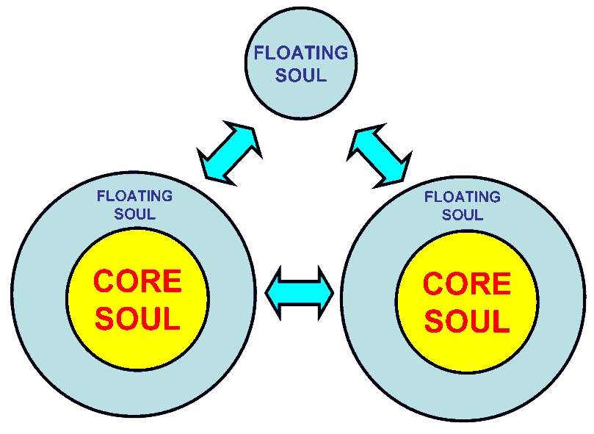

Core soul is solid. It remains after the death of life. But floating soul is not solid. It easily separates from solid core soul after the death of life. Floating soul that separated from core soul can join another soul. For example, if a human died, she or he will be reincarnated into another life such as a dog or a cat. In this process, floating soul separates from core soul. This is because brain of a dog or a cat is too small to accept core souls and floating soul of human. After the reincarnation into dog or soul, she or he will die again. Finally, she or he will be reincarnated into a human again. In this process, the core soul remains solid and do not separate each other. On the other hand, floating soul separates from core soul. So we lose many memories after we died. Namely, many memories are kept by the floating soul. On the other hand, basic character is kept by the core soul. So the character does not change after reincarnation. Namely, her or his character is basically same as that of her or his previous human life because the core soul is same. Life evolves from primitive lives such as ameba to more sophisticated life such as cat, dog, human. In this process, core soul grows.
If a human died, her or his soul separates from body. In this situation, in a sense, the soul is in the spirit world. I used the world "spirit world" in some other literatures I wrote. But, in this paper, my though has changed. There is no spirit world. But there are souls that are in the situation of being in the spirit world. Namely, souls that have separated from life are staying everywhere on the earth and in the universe. Needless to say, they are invisible. They are not in the spirit world but in our real world. So, in the future, we may be able to see soul that are out of life. We cannot see the black hole because it does not allow light to leave it. But we can identify the black hole by an indirect method. Similarly, we may be able to see the soul.
It is said that when we think something, weak electricity flows in neuron. Recently, we can control a simple car by detecting the electricity in brain. Namely, the car is controlled by the electricity in brain. It is said that there are a hundred billion neurons in human brain. Present science cannot analyze all the function of the neurons. It seems that scientists are trying to identify circuit of neurons. Recent progress of medical equipment such as MRI improved the analysis of brain. But present analysis of brain cannot find the cause of mental illness such as schizophrenia. This seems to be because scientists think that the brain is consciousness itself or mind itself. I think that the brain is interface between soul and body of life. Soul is staying in various parts of brain and moves in the brain. Neuron is corridor or way for movement of brain. If we think something, soul moves from a part of brain to another part of brain. So, if a certain part of brain is damaged, soul moves to other pars. Sometimes this makes brain have incredible ability. For example, when the left side of brain is damaged seriously, soul moves to the right side of brain, and this give the brain incredible ability of memory or calculation. Actually, some people have this type of ability after injury of left brain. This is caused by the movement of soul in brain. This movement of soul causes the weak electricity in neuron. If we think like this, we can understand the cause of schizophrenia. If two groups of soul exist in a bran, this is the schizophrenia. Namely, there are two core souls in a brain.
By the way, I think, difference of male and female is based by the difference between Plus Unit Soul and Minus Unit Soul. Plus Unit Soul and Minus Unit Soul are the most basic entity of this world. So, there are male and female. So we can think that no matter how the science develops, we must get old and die and there are male and female in this world. If we want to be happy, we must build a healthy woman-man relation and have a healthy family. If girls and boys have unhealthy sexual relation without marriage, our society as a whole becomes lonely or empty.

3. Reincarnation

Here, I would like to write about the reincarnation. Some people believe the reincarnation and some people do not. Which opinion is correct? I think both are correct. Namely, some people are reincarnated after few days, and some people are reincarnated after hundreds of millions of years. If a human is not reincarnated for hundreds of millions of years, the reincarnation does not exist virtually. People are instinctively feeling about the world after their death. Some people say that life is only one time. This is because she or he is instinctively feeling that she or he will not be reincarnated in the near future. Or, when a person is going to die, some people say, "I don’t want to die. I don’t want to die". Also she or he is instinctively feeling that she or he will not be reincarnated in the near future. On the other hand, some people say, "I will become an astronaut in the next life. In the life after the next life, I will become a powerful politician". Or, some people say, "I will be earnest and do not commit any crime in order that I will be reincarnated happily in the next life". These people are instinctively feeling that they will be reincarnated again and again. Both people are correct because some people are reincarnated after hundreds of millions of years and some people are reincarnated after one week.
Then who will be reincarnated soon? And who will be reincarnated after a long time such as hundreds millions of years? Basically, earnest people who did good things are reincarnated soon. Contrary to this, people who committed crime are reincarnated after a long time. Furthermore, an important point is that some people are reincarnated happily and some people are reincarnated unhappily. For example, some people are reincarnated healthily and into a rich family. On the other hand, some people are reincarnated as a handicapped baby and into a poor family. What will decide these differences? Basically, the mind of Unit Souls decides this. The Unit Soul have a desire to be happy. This desire allows good-natured souls to be reincarnated happily. Needless to say, this explanation does not explain the mechanism of making reincarnation happy or unhappy. But, basically, people with good behavior are reincarnated happily. This is same as the doctrine of many religions.
Besides these things, there is an important factor. Namely, if the earth disappeared or became uninhabitable, where can we be reincarnated? If the earth disappeared or became uninhabitable, our soul must go somewhere. In this case, our soul must find an inhabitable planet in the universe. So, some souls find the inhabitable planet soon. But some souls must look for the planet mostly forever. They must wander around the universe. This situation is so-called the hell. If wandering souls reach an inhabitable planet, they will make primitive lives and evolve to higher lives. Some souls will find a new planet easily by the help of Unit Souls. Namely, this is the work of god. Unit Souls are everywhere in the universe. They affect the orbit of planets around the star. Namely, by the help of Unit Souls, planet can be on the correct orbit. Furthermore, souls that are looking for new inhabitable planet are helped by Unit Souls if the soul are good natured. If we think like this, we can say that the universe was made by the god.

IV CONCLUSION

The most important topic in this paper is the essence of gravity. The source of power of gravity is the power of Unit Soul. The Plus Soul and the Minus Soul attract each other. This power of attraction cannot be analyzed by the science of present age. In the future, science may analyze it. So this power was assumed and theory was constructed on the basis of this assumption.
Plus Unit Soul and Minus Unit Soul attract each other. There are Plus Unit Soul and Minus Unit Soul in every matter. So matters such as the earth and the moon attract each other. This is the essence of the gravity.
In the process of thinking of the essence of gravity, ideas on Plus Unit Soul and Minus Unit Soul, on the evolution of life and soul, on the reincarnation, etc. emerged in my mind. So I wrote them.

SELECTED BIBLIOGRAPHY

In English

American Bible Society. Holy Bible. New Revised Standard Version. New York: American Bible Society, 1989.
Kaku Michio. The Future of the Mind. First Anchor Books Edition. New York: Anchor Books, 2015.
Rindler, Wolfgang. Relativity: Special, General, and Cosmological. 2nd ed. New York: Oxford University Press Inc., 2006: reprint ed., New York: Oxford University Press Inc., 2007.
Suzuki Toshio. Soul Federation. Bloomington: Xlibris Corporation, 2010.
----------. “Time at the Light Speed”. http://www.w-g.jp/member/suzuki/time-at-light-speed.htm: World Government Institute, February 2015.
Wikipedia. “Theory of Relativity”. http://en.wikipedia.org/wiki/Theory_of_relativity: Wikipedia, 2007.

In Japanese

Oono, Yasumaro, and Arei, Hiedano. Kojiki. n.p.: n.p., 712.

The origin of idea of this paper is written in Toshio Suzuki, Soul Federation (Bloomington: Xlibris Corporation, 2010). This idea was developed further in Toshio Suzuki, “Time at the Light Speed” (http://www.w-g.jp/member/suzuki/time-at-light-speed.htm: World Government Institute, February 2015). And the idea in “Time at the Light Speed” was developed further in this “Unit Soul”.
American Bible Society, Holy Bible, New Revised Standard Version (New York: American Bible Society, 1989), 4 and 8, Genesis, The Old Testament.
Yasumaro Oono and Arei Hiedano, Kojiki. (n.p.: n.p., 712).
Wolfgang Rindler, Relativity: Special, General, and Cosmological, 2nd ed. (New York: Oxford University Press Inc., 2006; reprint ed., New York: Oxford University Press Inc., 2007), 26.
For example, see Toshio Suzuki, Soul Federation, 82.
For example, see Michio Kaku, The Future of the Mind, First Anchor Books Edition (New York: Anchor Books, 2015), 140-3.

